

Faculty of Engineering and Technology

Department of Electrical and Computer Engineering

Computer Networks (ENCS3320)

**Project 2 Report**

**Prepared by:**

* **Abdallah Abualwalaya**
  + SID : 1201240
  + Instructor : Dr. Mohammad Jubran
  + Section : 3
* **Ali Kok**
  + SID : 1220375
  + Instructor : Dr. Mohammad Jubran
  + Section: 3
* **Qasem** 
  + SID : 1230486
  + Instructor : Dr. Mohammad Jubran
  + Section: 3

Contents

**Abstract:** 4

**Theory and Procedure:** 5

Networking Fundamentals 5

IP Addressing and Subnetting 5

Routing and Routing Protocol 5

Network Devices and Their Configuration 6

Subnet Table 6

**Theory and Procedure:** 7

**Conclusion:** 27

**Table of Figures**

**Figure 1: Static IP configuration for Printer_ECE** 7

**Figure 2: Static IP configuration for Printer_CS.** 8

**Figure 3: Dynamic IP configuration for an ECE network end device.** 9

**Figure 4: Dynamic IP configuration for an CS network end device.** 10

**Figure 5: Static IP configuration for an R0_IT router port.** 11

**Figure 6: Static IP configuration for an R1_IT router port.** 12

**Figure 7: Successful Ping results within the Faculty of Engineering and Technology network.** 13

**Figure 8: IP configuration of DHCP servers.** 14

**Figure 9: IP configuration of DNS servers.** 15

**Figure 10: IP configuration of Email servers.** 16

**Figure 11: IP configuration of Web servers.** 17

**Figure 12: Email service with the user setup on the mail.it.birzeit.edu.** 18

**Figure 13: DNS service with the RRs on the dns.it.birzeit.edu.** 19

**Figure 14: DHCP service with the pools on the dhcp.it.birzeit.edu.** 20

**Figure 15: Static IP configuration for PC_Home.** 21

**Figure 16: Dynamic IP configuration for a home network end device.** 22

**Figure 17: Static IP configuration of the R_Home router port.** 23

**Figure 18 NAT Table of R_Home Router** 24

**Figure 19: Successful Ping results between home network devices.** 25

**Figure 20 Email Client Configuration for gmail and it.birzeit.edu accounts** 26

**Figure 21 Successful sending and receiving of Emails.** 27

**Figure 22: Wireless network configuration for ENCS3320Home.** 28

**Figure 23: Successful access to www.it.birzeit.edu from a home network end device.** 29

# **Abstract:**

This report details a network topology simulation conducted in Cisco's Packet Tracer, aiming to apply fundamental networking principles. The project involved designing a segmented network with routers, switches, and servers, emphasizing IP subnetting and routing protocols like OSPF. Key tasks included configuring network devices, establishing connectivity, and integrating DNS, HTTP, and email services. The successful implementation demonstrated practical networking skills, efficient IP address utilization, and effective communication across the network. This exercise provided valuable insights into network setup and management, reflecting the application of theoretical concepts in a simulated environment.

# **Theory and Procedure:**

## Networking Fundamentals

This project centered on the basics of computer networking, focusing on connecting devices for seamless data sharing. We explored how various network topologies influence data flow, stability, and fault tolerance. These theoretical insights guided our approach to designing an efficient and functional network model in Cisco Packet Tracer. The chosen topology ensured optimal device interconnectivity while minimizing latency and packet loss.

## IP Addressing and Subnetting

In our project, IP addressing and subnetting were crucial for efficient network organization and management. Each device in the network was assigned a unique IP address to ensure accurate data routing and device identification. Subnetting allowed us to break the network into smaller, logical segments, enhancing security, performance, and scalability. These segments simplified troubleshooting and minimized broadcast traffic. By utilizing subnetting techniques, we optimized IP address allocation and created a structured network that was simulated effectively in Packet Tracer.

## Routing and Routing Protocol

Routing protocols, particularly **OSPF (Open Shortest Path First)**, were utilized in the project to determine the best paths for data transmission across the network. OSPF's dynamic nature allowed it to adapt to changing network conditions, ensuring reliable and efficient data flow. This protocol enabled seamless communication between different subnets and autonomous systems, ensuring that the network maintained high availability and minimized latency. The correct implementation of routing protocols in Packet Tracer was critical to achieving a functional and robust network.

## Components and Methods

• **Routers and Switches**: These devices were used to interconnect network segments, facilitating communication between different subnets and providing network stability.

• **Servers**: Web, DNS, DHCP, and mail servers were configured to provide essential services like IP address allocation, name resolution, and email communication.

• **End Devices**: PCs, laptops, and smartphones were added to simulate real-world user interactions within the network.

• **Simulation Tools**: Cisco Packet Tracer was used to design and simulate the network. Its visualization and simulation features helped us monitor data flow and test configurations.

• **NAT and ACLs**: Network Address Translation (NAT) and Access Control Lists (ACLs) were employed to manage traffic between private and public networks, ensuring security and efficient routing.

## Justification of Components

* **Routers** were critical for determining the best paths for data transmission.
* **Switches** provided reliable connectivity within local network segments.
* **Subnetting** ensured efficient use of the IP address space and enhanced security.

**OSPF Protocol** enabled dynamic routing, reducing manual intervention in path selection.

## Diagrams and Flowcharts

Figures such as network topology diagrams and flowcharts illustrating data flow between devices were used to visually represent the solutions. These diagrams helped explain the relationship between components and their roles in the overall network.

## Subnet Table

|  |  |  |  |  |  |
| --- | --- | --- | --- | --- | --- |
| Subnet | Subnet Mask "Using the slash notation" | Network IP | Broadcast IP | First IP | Last IP |
| ECE | 255.255.255.128 → 180.75.72.0/25 | 180.75.72.0 | 180.75.72.127 | 180.75.72.1 | 180.75.72.126 |
| CS | 255.255.255.192 → 180.75.72.128/26 | 180.75.72.128 | 180.75.72.191 | 180.75.72.129 | 180.75.72.190 |
| Servers | 255.255.255.224 → 180.75.72.192/27 | 180.75.72.192 | 180.75.72.223 | 180.75.72.193 | 180.75.72.222 |
| Backbone | 255.255.255.252 → 180.75.72.224/30 | 180.75.72.224 | 180.75.72.227 | 180.75.72.225 | 180.75.72.226 |

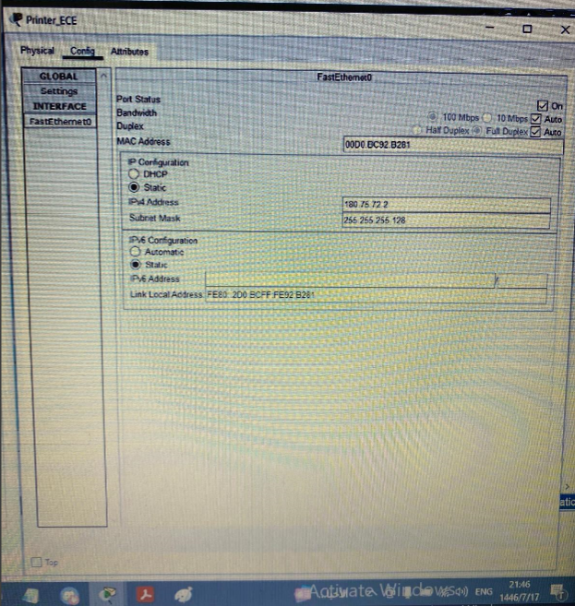

**Figure 1: Static IP configuration for Printer_ECE**

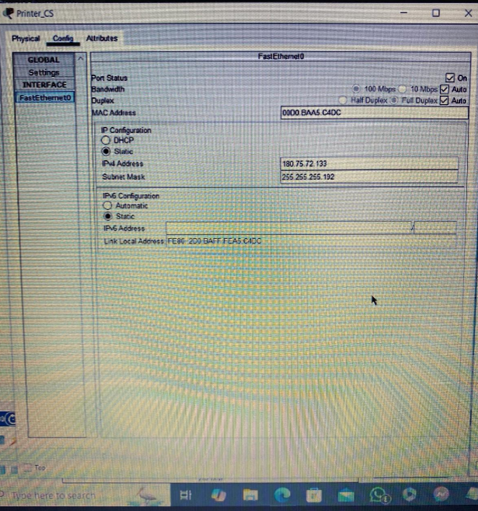

**Figure 2: Static IP configuration for Printer_CS.**

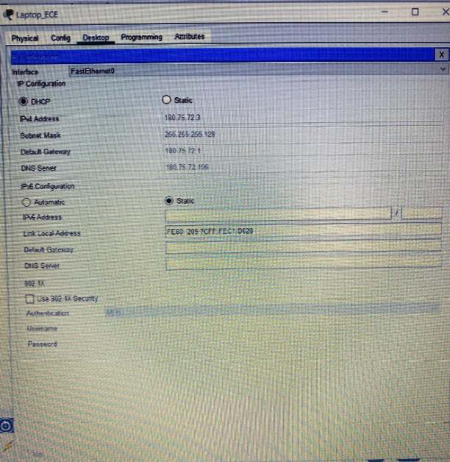

**Figure 3: Dynamic IP configuration for an ECE network end device.**

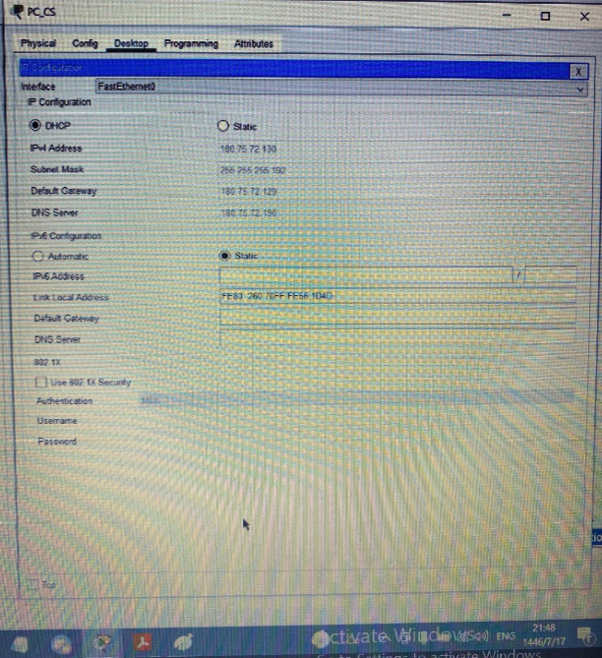

**Figure 4: Dynamic IP configuration for an CS network end device.**

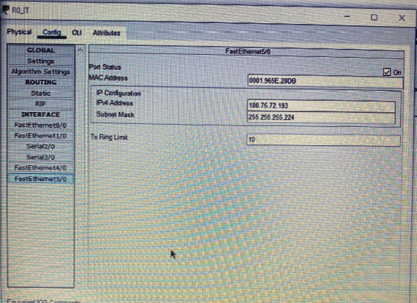

**Figure 5: Static IP configuration for an R0_IT router port.**

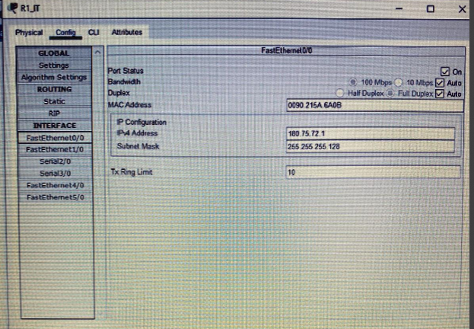

**Figure 6: Static IP configuration for an R1_IT router port.**

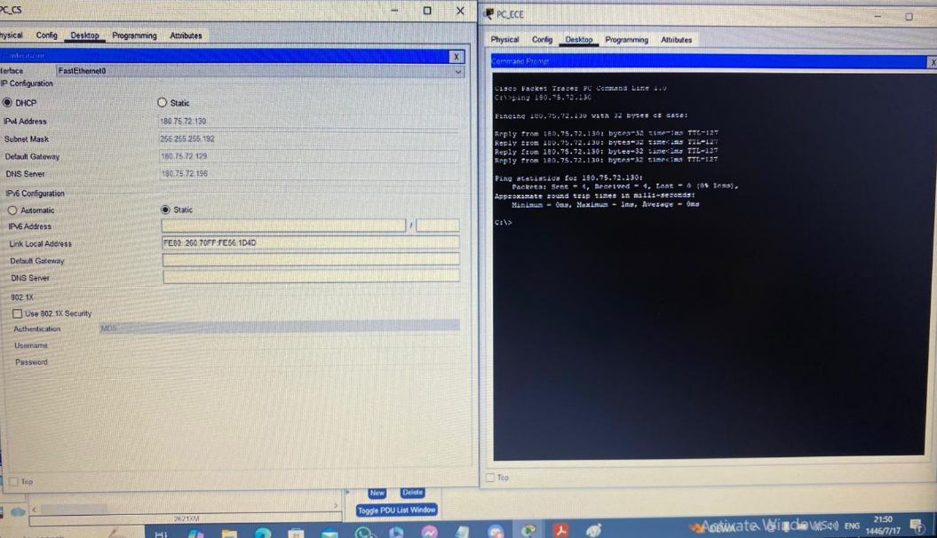

**Figure 7: Successful Ping results within the Faculty of Engineering and Technology network.**

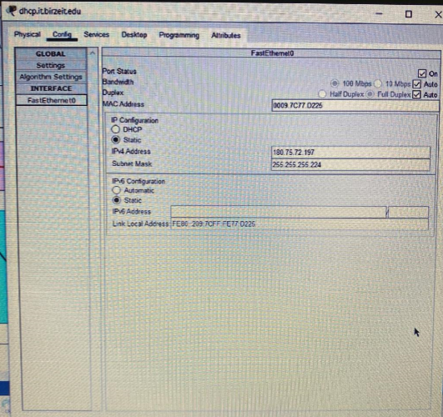

**Figure 8: IP configuration of DHCP servers.**

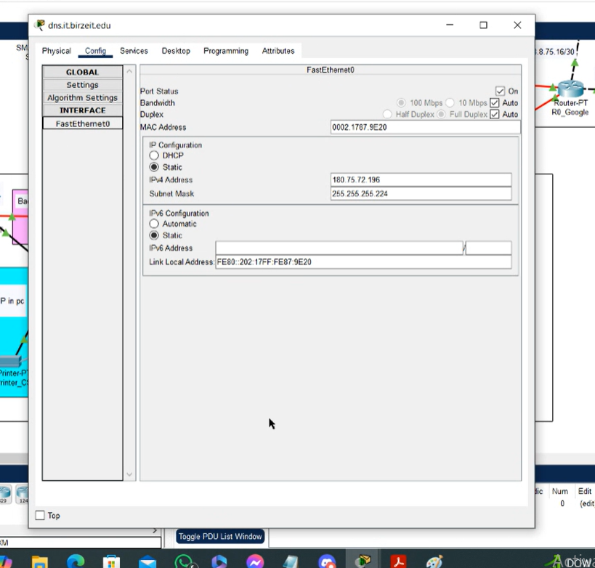

**Figure 9: IP configuration of DNS servers.**

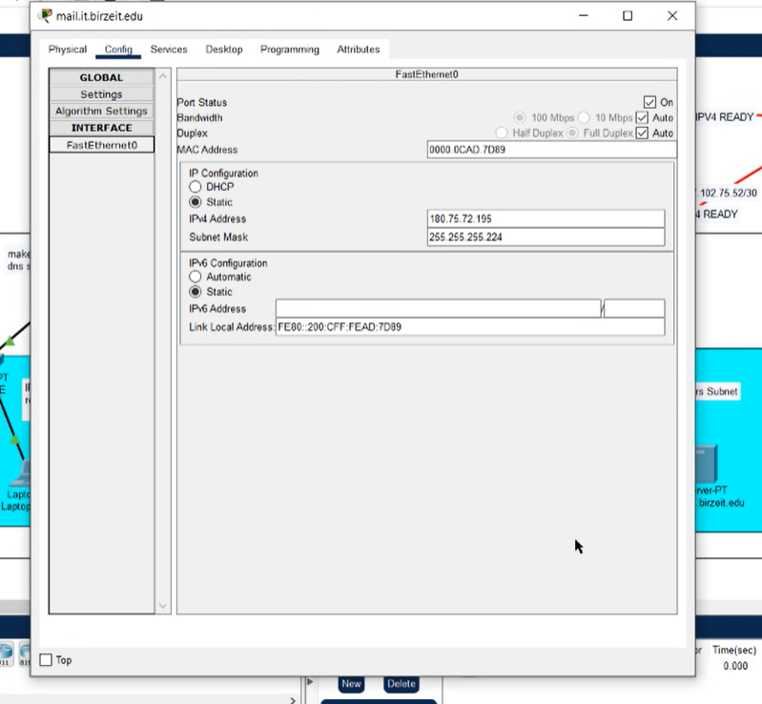

**Figure 10: IP configuration of Email servers.**

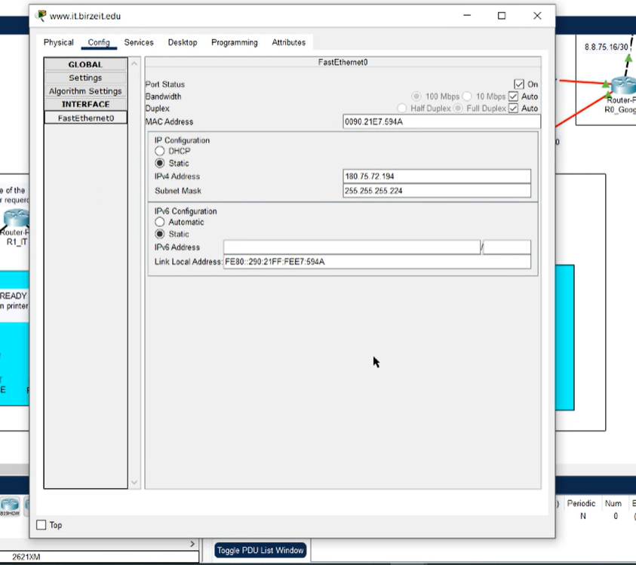

**Figure 11: IP configuration of Web servers.**

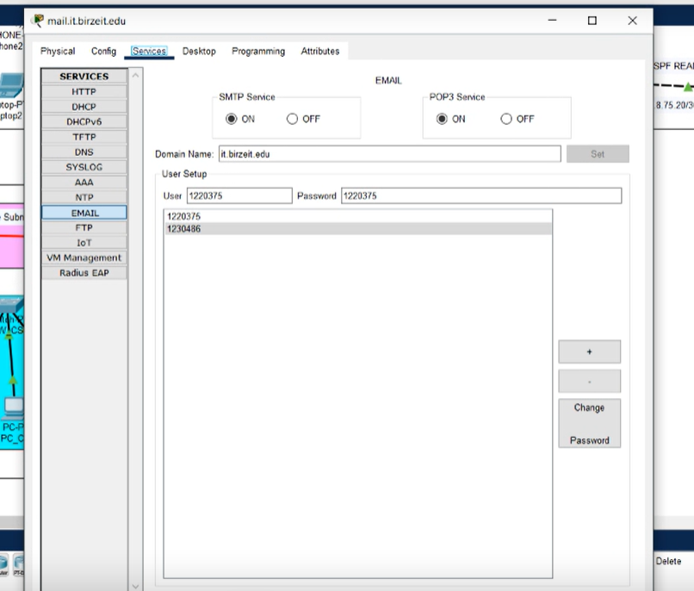

**Figure 12: Email service with the user setup on the mail.it.birzeit.edu.**

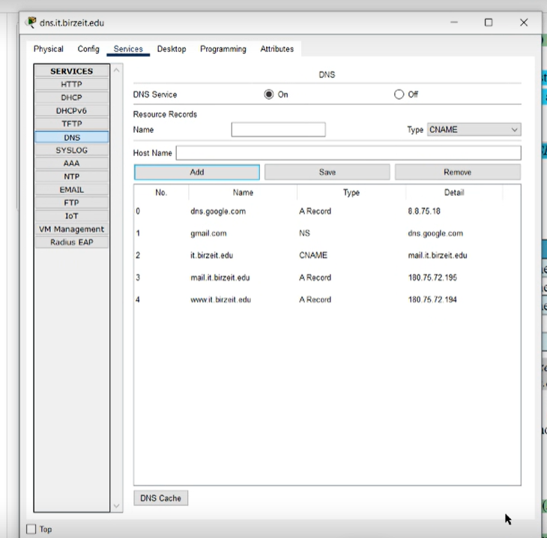

**Figure 13: DNS service with the RRs on the dns.it.birzeit.edu.**

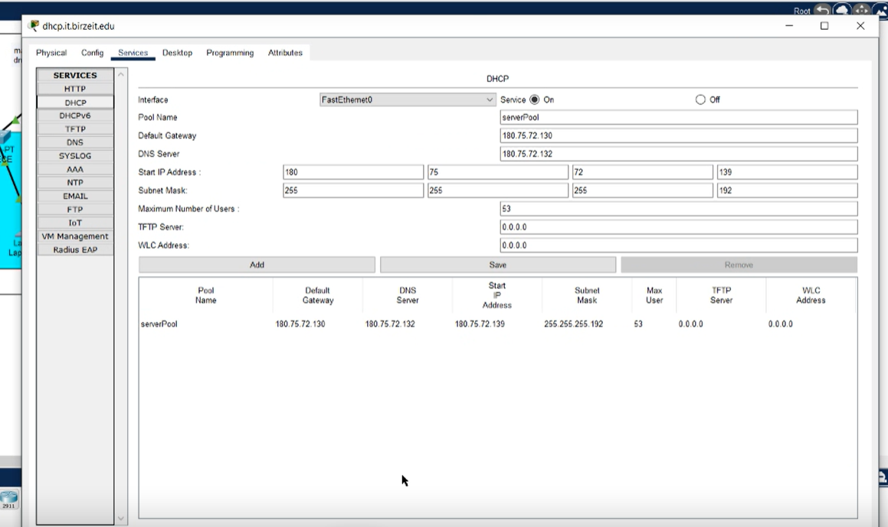

**Figure 14: DHCP service with the pools on the dhcp.it.birzeit.edu.**

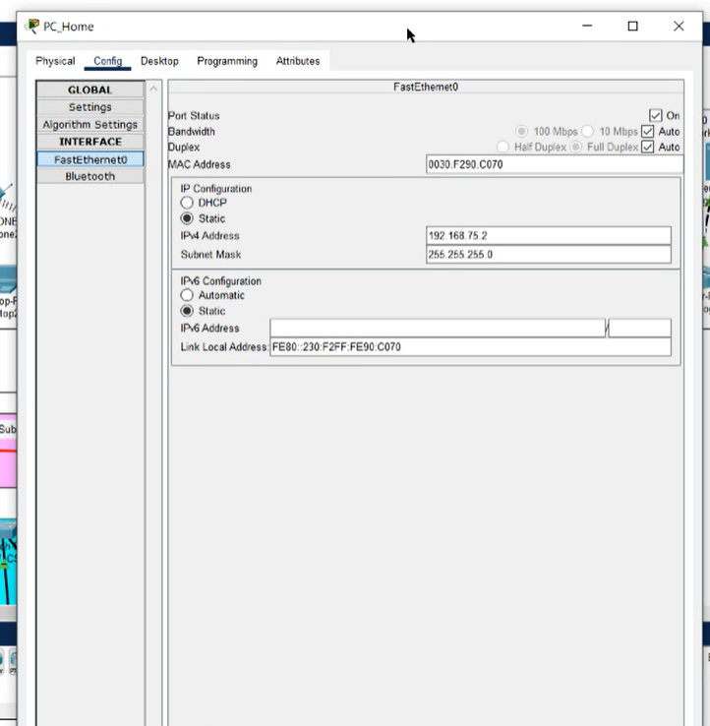

**Figure 15: Static IP configuration for PC_Home.**

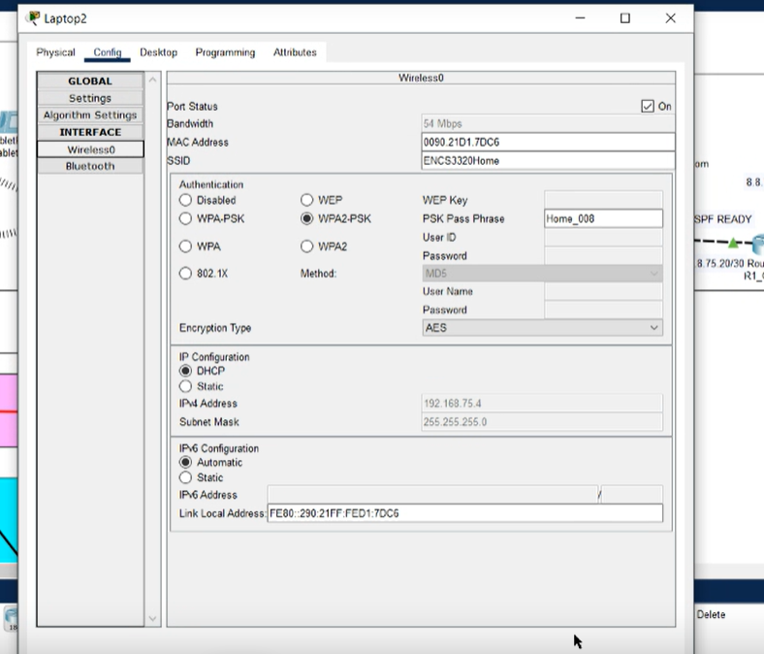

**Figure 16: Dynamic IP configuration for a home network end device.**

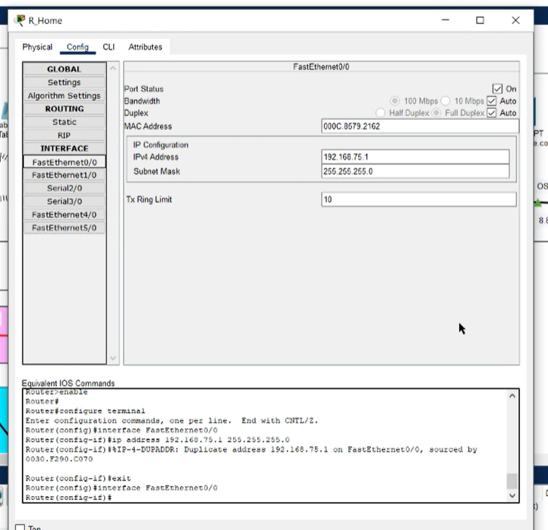

**Figure 17: Static IP configuration of the R_Home router port.**

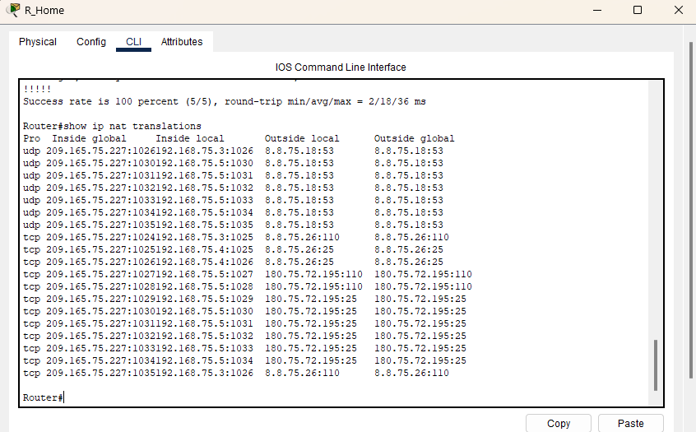

**Figure 18 NAT Table of R_Home Router**

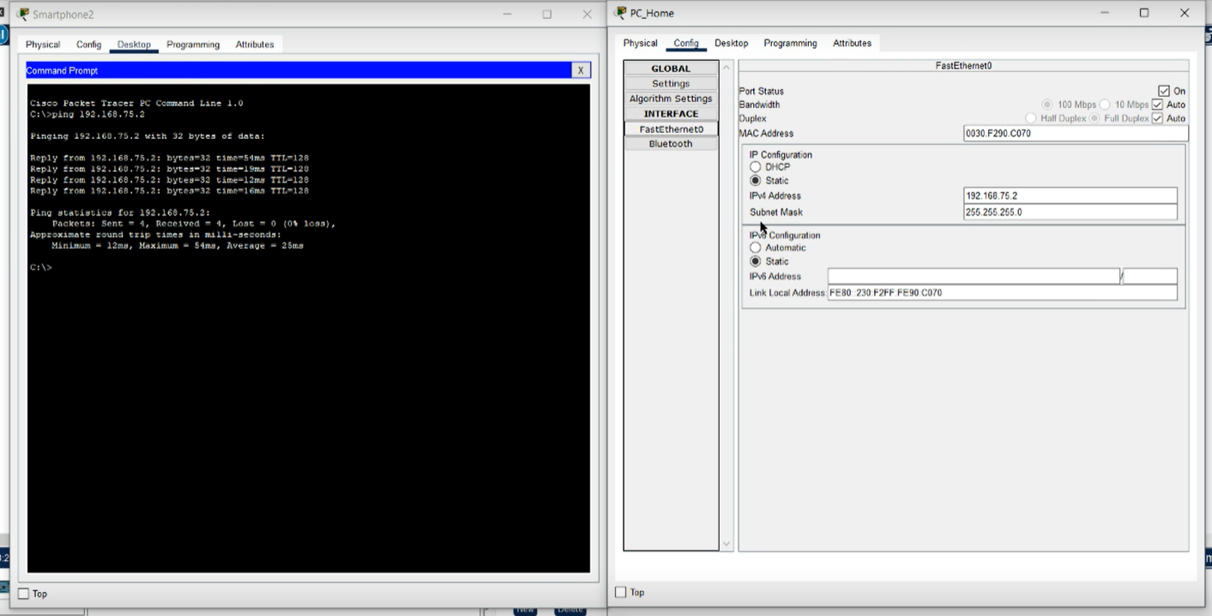

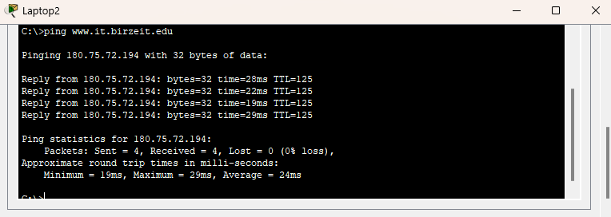

**Figure 19: Successful Ping results between home network devices.**

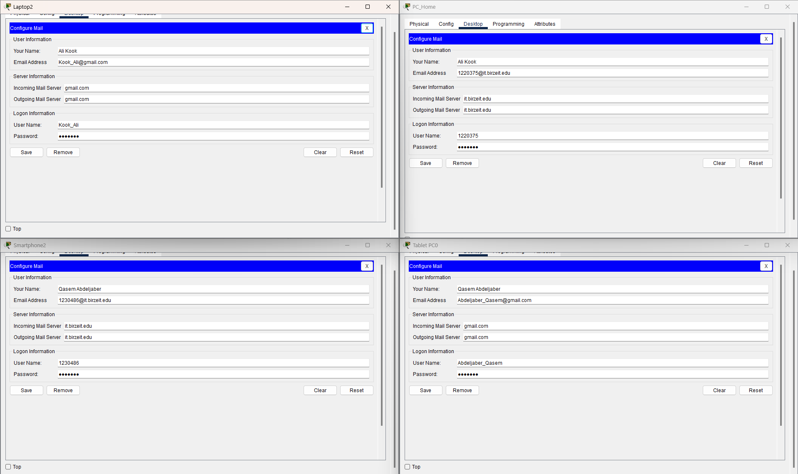

**Figure 20 Email Client Configuration for gmail and it.birzeit.edu accounts**

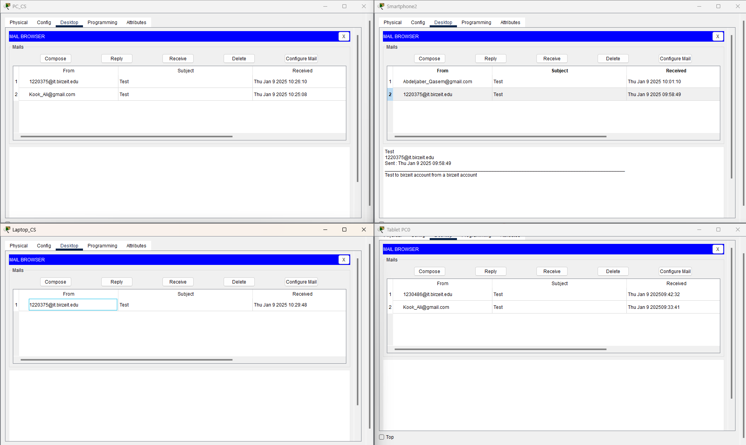

**Figure 21 Successful sending and receiving of Emails.**

**On the left side are the faculty emails and the right are the home emails.**

**Simulation Mode Observation:**

In Simulation Mode, sending an email from a gmail.com account to an it.birzeit.edu account involves a sequence of messages. First, the sender's device queries the DNS server to resolve it.birzeit.edu to its IP address. The DNS server responds with the IP, and the sender's email client uses SMTP to transfer the email to the it.birzeit.edu mail server. Finally, the recipient's device retrieves the email from the it.birzeit.edu mail server using the POP3 protocol. Clearing the DNS cache before the simulation ensures the full DNS resolution process is captured, validating the functionality of DNS, SMTP, and POP3 protocols.

**Findings and Observations:**

The email was successfully sent from the Home-ISP network and retrieved on both the Home-ISP and Faculty of Engineering and Technology networks. This confirms that the mail servers, DNS configurations, and routing between the networks are functioning correctly. No issues were encountered during the process.

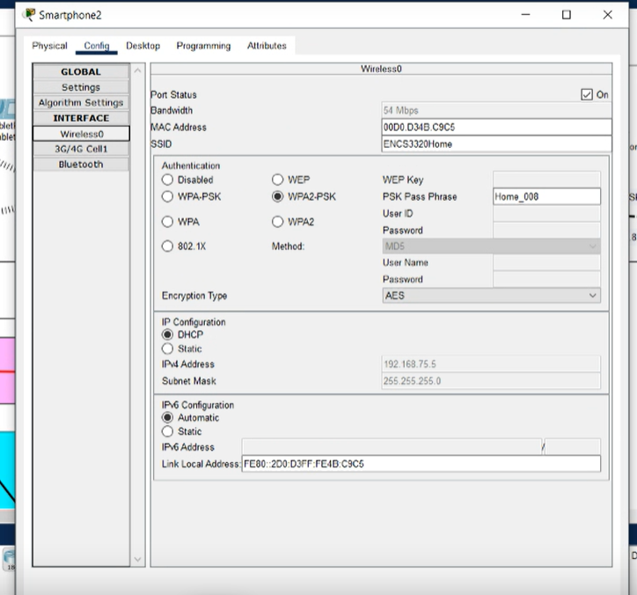

**Figure 22: Wireless network configuration for ENCS3320Home.**

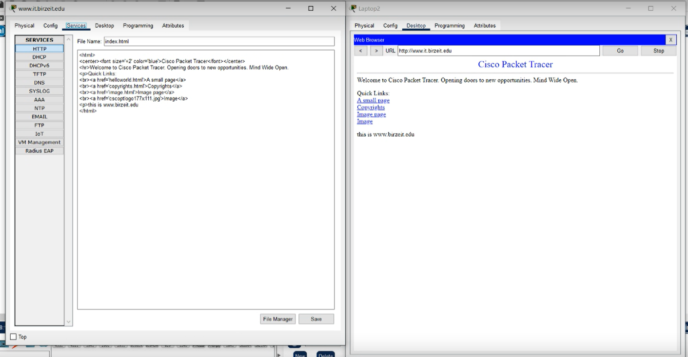

**Figure 23: Successful access to www.it.birzeit.edu from a home network end device.**

# **Result and Discussion:**

This project involved a thorough emulation of a computer network using Cisco Packet Tracer, where key concepts of networking were practically applied. The primary objective was to design and implement a fully functional network that included subnetting, routing, and server configurations to enable seamless communication between devices across multiple networks.

**Network Design and Configuration**

The project began with configuring routers, which formed the foundation of the network. This step required an understanding of the physical and logical structure of routers, including their interfaces and roles in connecting different devices. Using the provided student IDs, the required number of subnets was determined, and IP addresses were allocated to ensure efficient network organization. These unique addresses facilitated accurate routing of data within the network.

**IP Addressing and Subnetting**

Subnetting played a pivotal role in dividing the network into smaller, logical segments tailored to specific needs, such as the Faculty of Engineering and Technology and the Home-ISP networks. This method ensured optimal utilization of IP address space, reduced unnecessary broadcast traffic, and enhanced overall network efficiency. Subnetting also simplified troubleshooting by isolating traffic within distinct segments.

**Routing and Protocol Implementation**

Dynamic routing protocols, particularly **OSPF (Open Shortest Path First)**, were implemented to manage data flow between subnets effectively. OSPF dynamically determined the best paths for data transmission, ensuring adaptability and reliability in communication. Additionally, static routes were configured to enable seamless communication between autonomous systems. These measures provided a balance between automated efficiency and manual control.

**Server Configuration**

Key network services were provided by configuring the following servers:

* **DNS Server**: Allowed devices to resolve domain names like it.birzeit.edu into IP addresses, enabling smooth access to services.
* **Email Server**: Enabled email communication within and between networks. Both SMTP (for sending emails) and POP3 (for retrieving emails) were configured and tested successfully.
* **HTTP Server**: Hosted a custom-designed webpage related to the Faculty of Engineering and Technology, accessible from all networks.
* **DHCP Server**: Automated IP address allocation, simplifying device configuration and ensuring consistent network connectivity.

**Packet Movement and Simulation**

Using Packet Tracer’s **Simulation Mode**, we observed the flow of packets between devices, including DNS queries, SMTP communications for email delivery, and POP3 interactions for email retrieval. This simulation validated the correct functionality of all network components. For example, packets were successfully routed from the Home-ISP network to the Faculty of Engineering and Technology network and back, demonstrating proper routing and service availability.

**Email Communication**

One of the core tests involved sending emails between accounts in the Home-ISP and Faculty networks. This required precise configuration of mail servers and DNS records. After extensive testing, emails were successfully sent and retrieved, confirming the effectiveness of the network design and server configurations.

**Troubleshooting and Challenges**

Several challenges were encountered and resolved during the project:

* **DNS Issues**: Addressed by ensuring the DNS server contained accurate A records for domain resolution.
* **Routing Misconfigurations**: Corrected by verifying and updating static and dynamic routes.
* **NAT and ACL Problems**: Resolved by fine-tuning NAT rules and access control lists to allow traffic between private and public networks.

**Outcomes and Observations**

The project demonstrated the importance of precise configuration and validation in building a reliable network. Key observations include:

1. The effective use of IP addressing and subnetting to organize the network and optimize resources.
2. The significance of dynamic routing protocols like OSPF in maintaining seamless communication.
3. The critical role of server configurations in providing essential network services.

**Conclusion**

Through careful planning, implementation, and testing, the project achieved a fully functional network that facilitated seamless communication across devices and networks. The process provided valuable insights into practical networking, from topology design and routing to troubleshooting and server configuration. These skills will undoubtedly prove essential in future projects and real-world networking scenarios.

# **Result and Discussion:**

**Ali – 34%**

**Qasem – 33%:** Helped Abdallah with report.

**Abdallah – 33%:** Abdallah did majority of the report and the below is only a demonstration of work on the project itself, so his name won’t need a highlight color.

**The work split is demonstrated by highlighting the section with the team members corresponding colors.**

1. **Google Network (AS-300):**
   1. **Assign static IP configurations to all router ports.**
   2. **DNS Server (dns.google.com)**
   3. **Email Server (gmail.com)**
      1. **Enable only the SMTP (for sending emails) and POP3 (for receiving emails) protocols.**
      2. **Assign a static IP configuration.**
      3. **Set the domain name (mail server alias hostname) as gmail.com.**
      4. **Create two user accounts for team members**
2. **Faculty of Engineering and Technology Network (AS-100)**
   1. **The Faculty of Engineering and Technology has been allocated the IP block 180.X.72.0/24 from the Information Technology Department. The network topology is shown in Figure 1 and includes the following subnets, Servers Subnet, Electrical and Computer Engineering (ECE) Subnet, Computer Science (CS) Subnet, Backbone Subnet.**
   2. **Specific requirements for each subnet:**
      1. **Servers Subnet**
         1. **Web Server (**[**www.it.birzeit.edu**](http://www.it.birzeit.edu)**)**
         2. **Mail Server (**[**mail.it.birzeit.edu**](http://www.it.birzeit.edu)**)**
         3. **DNS Server (dns.it.birzeit.edu)**
         4. **DHCP Server (dhcp.it.birzeit.edu)**
      2. **ECE Subnet**
         1. **ECE computers need to know the printer’s IP address to send information to it. Thus, assign a static IP configuration to the printer.**
         2. **Use dynamic IP configurations for the PC and laptop (via DHCP).**
         3. **Configure the PC’s email client for the first Gmail account.**
         4. **Configure the laptop’s email client for the first Birzeit account.**
      3. **CS Subnet**
         1. **Assign a static IP configuration to the printer.**
         2. **Use dynamic IP configurations for the PC and laptop (via DHCP).**
         3. **Configure the PC’s email client for the second Gmail account.**
         4. **Configure the laptop’s email client for the second Birzeit account.**
3. **Home-ISP Network (AS-200)**
   1. **Configure the wireless network by setting up the access point with required parameters.**
   2. **Connect wireless end devices to the ENCS3320Home network and cabled end devices through the switch.**
   3. **Assign static IP configuration on the R_Home router interface to serve as a gateway for the home subnet.**
   4. **Set up the R_Home router as a DHCP server for the 192.168.X.0/24 network. Specifically, set up the DHCP pool with the default gateway and DNS server (Google’s DNS server discussed in Section C-1 (Google Network))**
   5. **Assign dynamic IP configurations to end devices.**
   6. **Configure the R_Home router for dynamic NAT with PAT to translate private IP addresses to a single outside address.**
   7. **Configure the email client on two end devices for accounts on gmail.com.**
   8. **Configure the email client on the other two end devices for accounts on mail.it.birzeit.edu.**
4. **Routing Configurations**